 | OXHEY BOWLS CLUB | 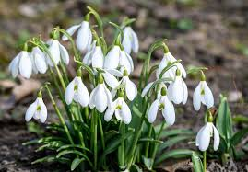
Newsletter No. 27 February, 2022
QUIZ  and  AFTERNOON TEA  SATURDAY 26TH FEBRUARY  1.30 FOR 2.00pm  Tea to include filled bridge roll, scone, cream and jam plus a pastry.  £5 per person  A list is in the Club House for you to put your name down. Marion can also add any names, just give her a ring. 01 923 443869.  ***  BLUE CHECK LUNCHEON  AND PRIZE GIVING  A quick reminder  Friday 4th February  12.30 for 1.00pm  Any raffle prizes gratefully received  There is ample parking across from the restaurant, charges apply, see photo below  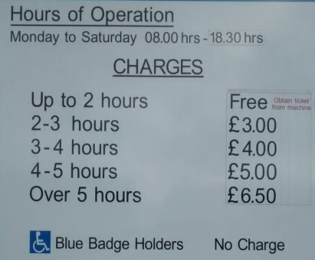  Editor: Marion Pugh 01 923 443869 | COFFEE MORNING  "We would like to thank all 26 members who came along to our first coffee morning of 2022, making it a great success.  Along with the bric-a-brac and jam sales etc. we managed to raise £141 all in aid of Macmillan Cancer Care.  We guarantee there will be more bacon rolls next time to ensure nobody goes home disappointed.  We look forward to seeing you all again on Friday 4th March at 10:00am.  Kind regards. Ken & Carole Horn."  CRIBBAGE MORNINGS  The gents crib mornings are proving very popular. Always room for more players.  Every Tuesday 10.00 – 12.00  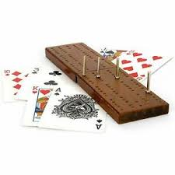  ***  February 100 Club Winner  Terry Miller  Winning number drawn at Monday Craft Meeting  www.oxheybowlsclub.co.uk

